

Design Document for:

Sari and Matrix

Explorer the voxel world !

All work Copyright © by Bunny and Squirrel

Written by SAKU

Version # 1.00

Sari and Matrix 1
Design History 4
Version 1.0 4
Game Overview 4
Philosophy 4
Philosophical point #1 4
Common Questions 4
What is the game? 4
Why create this game? 4
Where does the game take place? 4
How many characters do I control? 4
What is the main focus? 4
What’s different? 4
Feature Set 5
General Features 5
Editor 5
Gameplay 5
The Game World 6
Overview 6
World Feature #1 6
World Feature #2 6
World Feature #3 6
The World Layout 7
Overview 7
World levels 8
The forest 8
Puzzle 8
The camp 9
the cave 10
Puzzle 10
Game Characters 11
Overview 11
Sari 11
Background: 11
Weapon and skills: 11
Special ability: 11
Matrix 11
Background: 12
Weapon and skills: 12
Special ability: 12
Non-Player Characters 12
the owl 12
business man 12
Enemies and Monsters 12
Friendly animals 12
Predator 13
Stage boss 13
Weapons 13
Mechanics and Systems 14
Overview 14
The Physical World 14
Overview 14
Key Locations 14
Objects 15
Weather and time 15
Control 15
Camera 15
Story 15
Goal 15
Game Engine 16
Other tools 16

Design History

Version 1.0

Includes two level designs, characters, some weapon and the game play flow.

Game Overview

Philosophy

Philosophical point #1

This game is trying to do this and that. Fundamentally I am trying to achieve something that has never been achieved before. Or. This game will not try and change the world. We are ripping off the competition so exactly that I can’t believe it. The world will be shocked at how we are using an existing engine with new art.
This game is making a new look of this world, the voxel world cute and easy to explorer.
The pixel or voxel things are always calling up old times, and it's really amazing to have a new game in a nostalgic world.

Common Questions

What is the game?
This is a puzzle/action game which you can act as a voxel gothic Lolita Fashion girl and a gumball shooting dog, walking in the forest and find the truth of the world.

Why create this game?
It will be a new gift to these voxel/pixel lovers, who interesting in or just like old games.

Where does the game take place?
The voxel world everything appear in voxel look.

How many characters do I control?
Sari the girl as the main character, and Matrix the dog as the assistant. You can control them as a team and choose either of them as the team leader.

What is the main focus?
Fight, solve puzzles and find the truth.

What’s different?
See the world in a different way. The simple cube thing may also colorful.

Feature Set

General Features

Several types of the world, with several kinds of puzzles
Cube-like players
3D graphics

Editor

Comes with world editor, with large amount of terrain.

Gameplay

Explore and fight
Find the piece of memory
Operate machines to open a road
Several kinds of puzzles
Use right player at right place
Upgrade the armor and weapon by collect material

The Game World

Overview

The world in this game is depends on the real world but all looks in zombie green. All the creatures become anomalous except the player and some special character. The adventure of our hero is to find out what happened to this world.

World Feature #1

Four different worlds.
The world is divided to several parts; each hides a piece of memory. Each part of the world has four small levels and a stage boss in the forth level.

World Feature #2

All in voxel.
All things are voxel, cube animals, cube plants and cube rocks. All things show this world in a general way.

World Feature #3
Camps and portals.
After go through the first level, players can build a camp, where they can set portals and talk with NPCs.

The World Layout

Overview

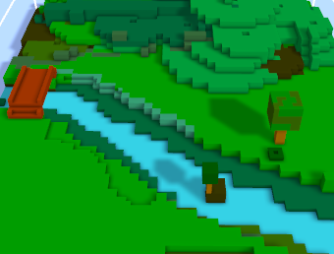
The voxel world, cube animals, cube plants and cube rocks. All things show this world in a general way.
There are four different worlds in this version. The cave, the city, the desert and the future. The forest is the train level and the camp as the transport hub.

World levels

The forest
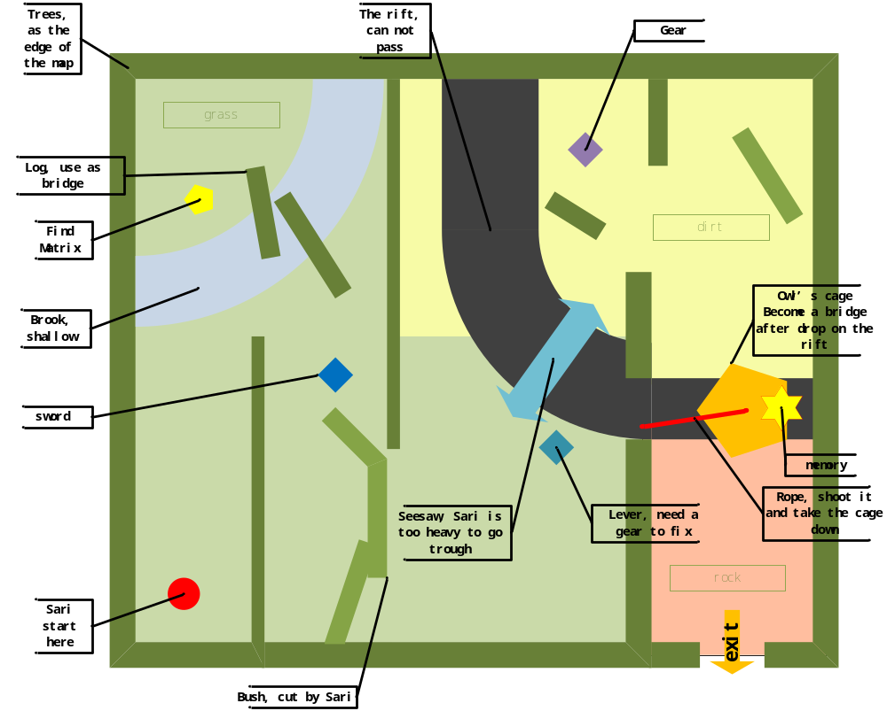
It is the train level which mainly shows how the world runs and tells very little story. A peaceful forest with sunshine through the leaves. Some ruins of city lay behind the trees. The world is all in silence expect the steps on the grass. The animals are friendly and shy.
Sari and Matrix wake up and start their journey here. The changes have not taken place for so long and the affect is not distinct. So the animals are not aggressive, and the environment is basically safe. Players can gather the character, and then find the weapon.

Puzzle
The seesaw:
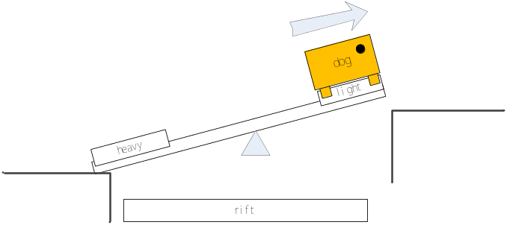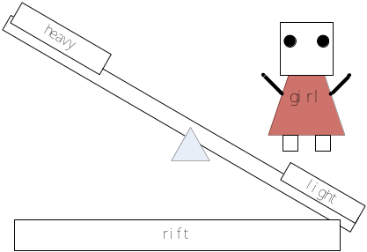
Matrix is light, so he can go through the seesaw, but Sari will fall down.
Send Matrix to the other side of the rift, and get the gear back. After that, the gear will fix the lever and the seesaw will be lock. Keep Sari in his sight while Matrix is working alone on the other side.

The camp

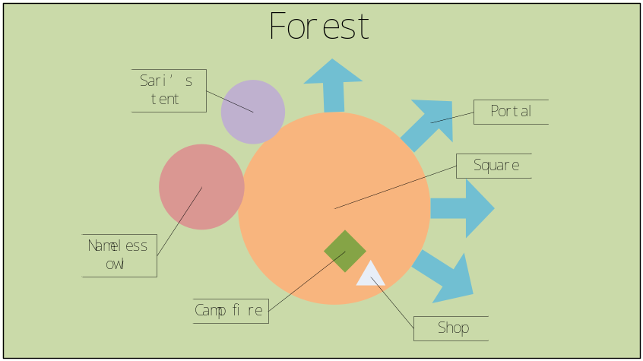
After go through, layers will build a camp, and the characters will live here.
When layers fine enough pieces of memories, the owl will open a portal to the next world. These portals will be opened one by one. After plays find the business man, they may sell some materials by the campfire occasionally.
Sari and Matrix can have a rest in the tent, just for seeing the baby face.

The cave
It is the sanctuary for human when the Tragedy strikes .there are marks of human activity but no human seem to be here. Empty cans and lay here and there, the echo will bring the dangers predators when someone kicks the cans.
The portal set Sari here and then they find the way out was blocked. The player should fight the enemy and find the exit in the maze. There are several paintings on the wall. While reading the paintings, Sari knows the history here.
There are 4 small levels here, each tells a part of the cave history. Plays can find more than 4 pieces of memory here, while four of them are easy to find. In the forth level, play will fight a predator boss.

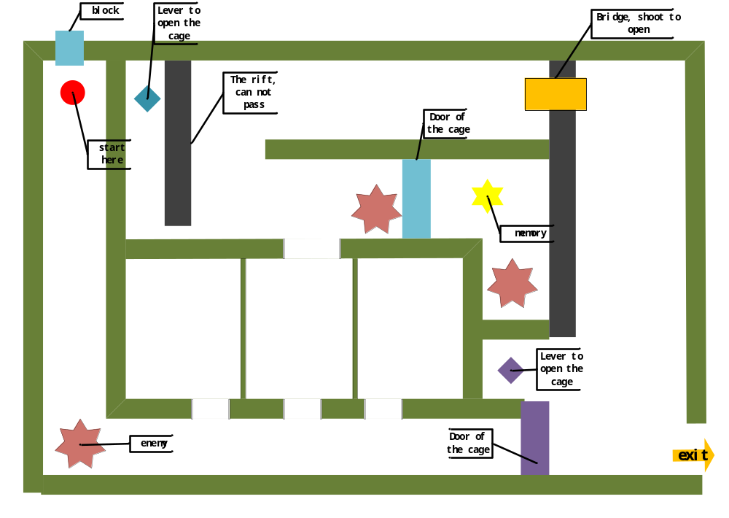
world 1 level 1

Puzzle
Maze:
This level is a maze after all.
Narrow way:
Send Matrix cross the hidden narrow way by the rift to operate the lever. Then the cage door will open and the memory piece can be got.

Game Characters

Overview

There are two players in this version. Sari the girl as the main character, and Matrix the dog as the assistant. You can control them as a team and choose either of them as the team leader.

Sari
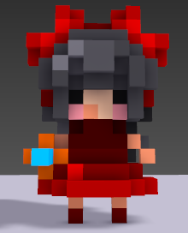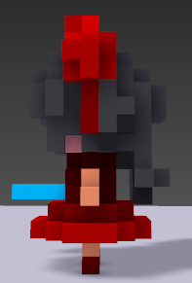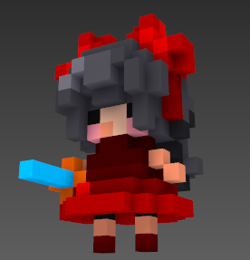
Sari the hero, an eight years old human girl, sword in hand and dress in finery. In this game, Sari takes the part of action.

Background:
Sari wake up and found herself in the forest and could not remember anything. The only thing with her is her pet Matrix. To get her memory back and find out why she stay here and what she would do.

Weapon and skills:
Sari can use all kinds of swords but no ranged weapon. She can pick up her first weapon in the forest when she meets her enemy the first time.
Sari can use normal attack and one special skill. The type of skill depends on the sword she using. Such as circle slash or sudden thrust.

Special ability:
Cross some special terrain, such as the thorny road and trapeze or tightrope in the air.

Matrix
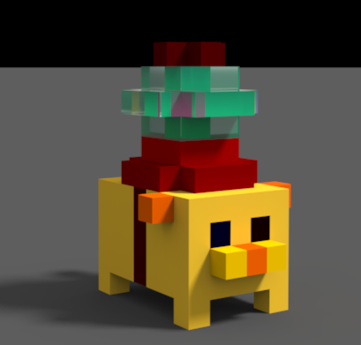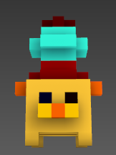
An elder pet dog of Sari, ten years old, looks like a cube in this voxel world .short legs and short tail. In this game, Matrix takes the part of puzzle.

Background:
Sari is his best friend and he will never leave her away. If he lost the sight of Sari for 5 seconds, Matrix will be too anxious to move until he can see Sari again.

Weapon and skills:
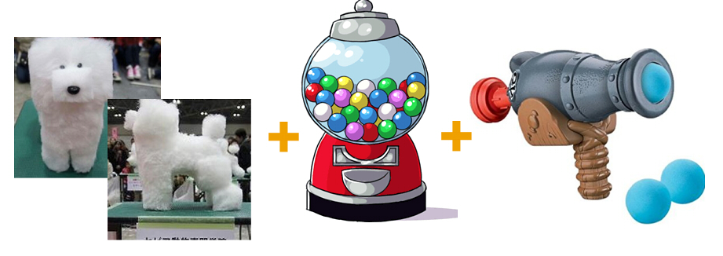
A gumball add a toy shooter

Matrix carries a toy canon on his back, so he can use ranged attack to make small damage. He can also bite or bark as a real dog when the targets are near.

Special ability:
As a dog, Matrix is alert and has the good sense of smell. When Matrix acts as the team leader, he can show the direction of treasure, and see some hidden things.
Transform is the most important ability of Matrix. He can learn from the environment and change his form to all the weapons or ancient ruins he meets. It is useful when solving puzzle, but if he cannot see Sari, his ability will invalid.

Non-Player Characters
When Sari and Matrix exploring the forest, they will face some kinds of enemy, or meet some mentor, business man and so on.

The owl
Mentor, the nameless owl, worthy of the forest.
It was trapped in the cage and set free by Sari. When Sari finds some piece of memory, she must take it to the owl to decode it.

Business man
Business men, hide in the forest and can be find by Matrix’s nose.
For some reason, they never use money but just exchange things. Sari can exchange or compound items with them.

Enemies and Monsters

Friendly animals

Such as bunny, rat, bird, and some other cute small peaceful creature, always in zombie green.
They attack when player hurt them and make a tiny damage.
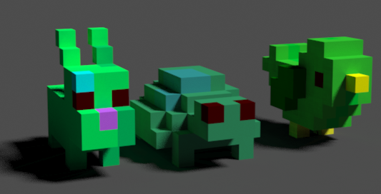
Bunny turtle and bird

Predator
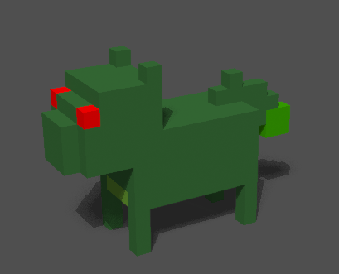
Bigger zombie animals, such as cat, snake, wolf. They attack the player when they go nearby.

Stage boss
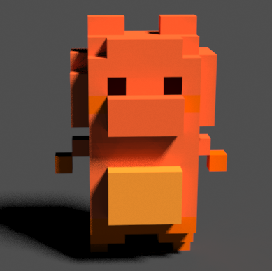
A cube bear as the first boss
Some large, strong creature which block the way to the next area.
They can be friendly or hostility, the player should take them down by solving puzzle or fighting.

Weapons

The players can find new kinds of weapon in new level; there are several themes in different world. Such as a cactus sword in the desert, a light saber in the future world.
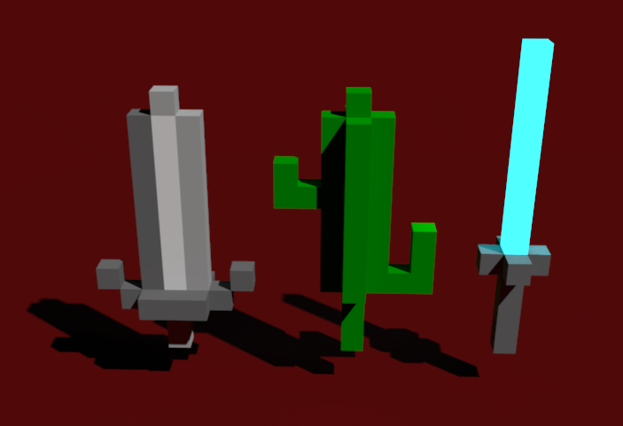
Sword, cactus sword and light saber

Mechanics and Systems

Overview
Main flow while play:
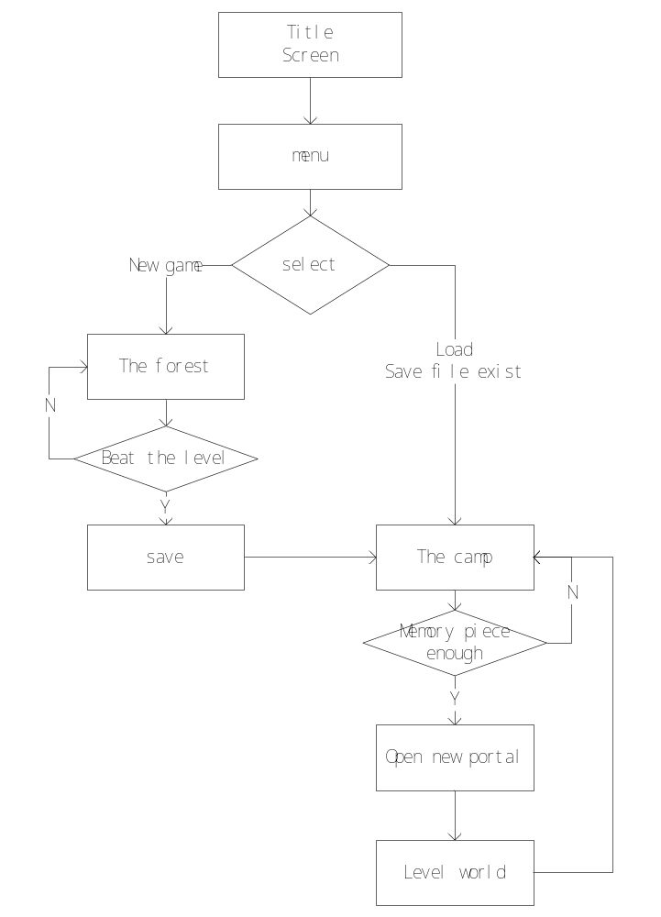
Use gamepad or keyboard, control the players moving and fighting.
Call the menu with key event while in level world.

The Physical World

Overview
There are several parts of the world; each has its own function.

Key Locations
The forest: the train level
The camp: transport hub. With a rest room, a mentor’s house, portals and a truck shop.
There are four level worlds in this version. The cave, the city, the desert and the future.

Objects

Lever: such as gear and button, do something to open the gate, traditional thing in a puzzle game.
Memory piece: necessary to open the next world portal.
Weapon: players can pick up in the level. Use them to fight with enemy or cut the bush, shoot some lever and so on.
Material: such as branch, stone and seed, can be found in the level. Buy or exchange things with business man.

Weather and time

There are some kinds of weather, like rain and wind in specific world or level.
It’s difficult to see far in the night, and players will be the easy target of the enemy.
In the windy days, control matrix will be more difficult because he’s light weight.
It’s cold in snow so players should always find a camping fire to stop losing temperature.

Control

Use gamepad or keyboard, control the players moving around and fighting.
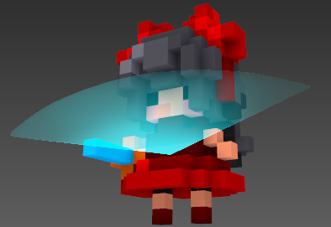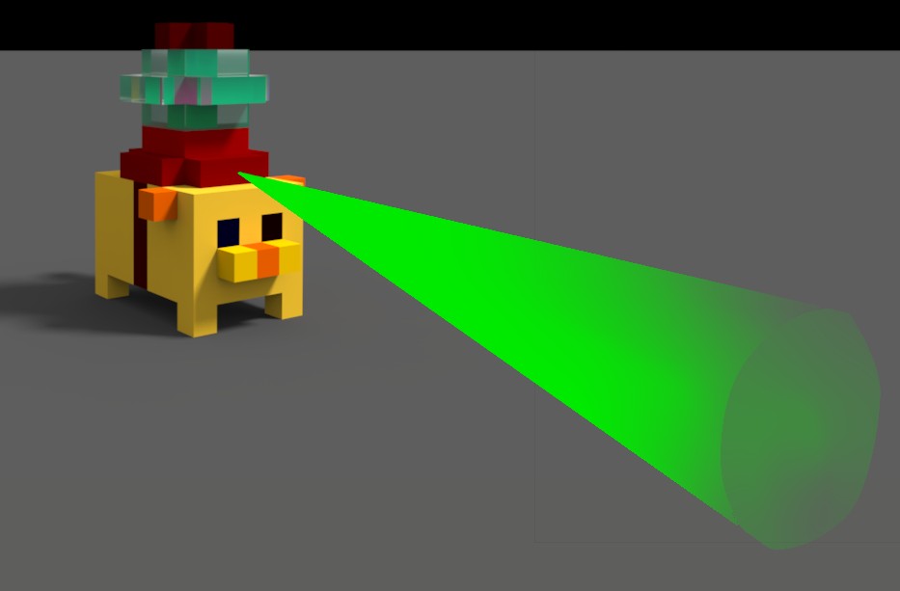
The attack range of Sari is a sector in front of her body.
The attack range of Matrix is a line in front of him and can attack for a longer distance.

Camera

This game run in a third person view, look down at the map and keep the player center.

Story

One day some unknown things crashed and tear the world apart, and the animals used to be friendly, was affected to become zombie like things. Sari woke up and found herself in the forest and could not remember anything. The only thing with her is her pet Matrix. To get her memory back and find out why she here and what she would do.

Goal
It is a puzzle& adventure game. The player need to explorer the world and cure it by solve puzzles and fight with the bad guy.
Keep alive and get to the exit to beat the level, and collect the piece of memory to unlock more worlds.

Game Engine

It will use unity in this vision. Easy to learn and do well in platform crossing.

Other tools

Magicavoxel: It’s such an amazing tool to create voxel model. It also can make texures.
3DS Max: to make animation, terrain

